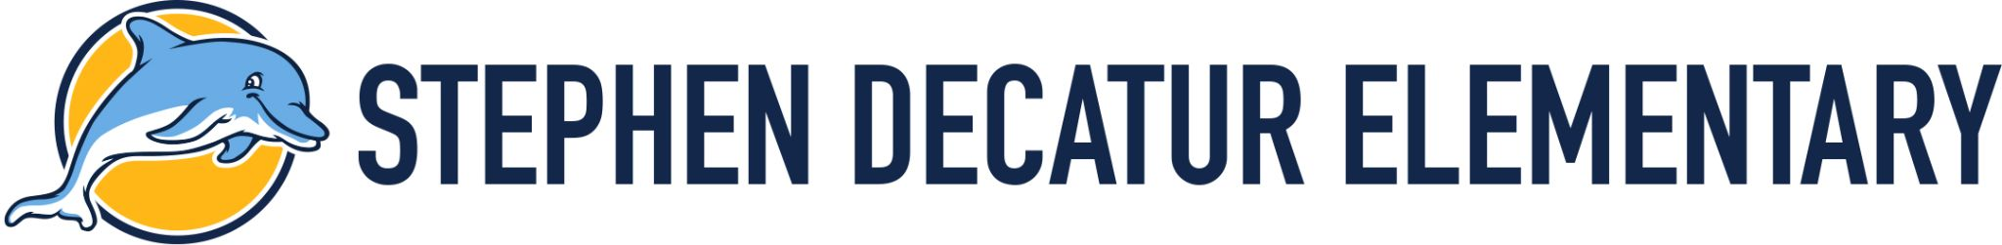
Room 310 Supply List

Welcome Back,

Below is the requested Supply list for the 2023-2024 school year.
Please feel free to add anything else you feel we might need for next year.
Materials:
5 Plastic Binders
- 5 Plastic Folders
- Dry Erase Markers
- Pencils
- Glue Stick
- Pencil Case
- Construction Paper
- Tissues
- Disinfecting Wipes
- Hand Sanitizer
- Crayons
- Old T-shirt ( for Classroom Art/Cooking Projects )
Please provide your child with a change of clothing. Label all clothing items with your child’s name.
2 pairs of underwear
- 2 pairs of socks
- 2 shirts
- 2 pairs of pants
Student preferred items:
- These items will be used during your child’s lesson..
- We will be using the preferred items sent into school as reinforcement for your child.
- Preferred Items can be anything you child will work for during the school year:
  - Toy, Puzzle, Favorite Disney Character
  - If there is a preferred food item (like crackers, cookies, cheese it, etc….) will use these items for reinforcers throughout the day.
Thank you,
Room 310

