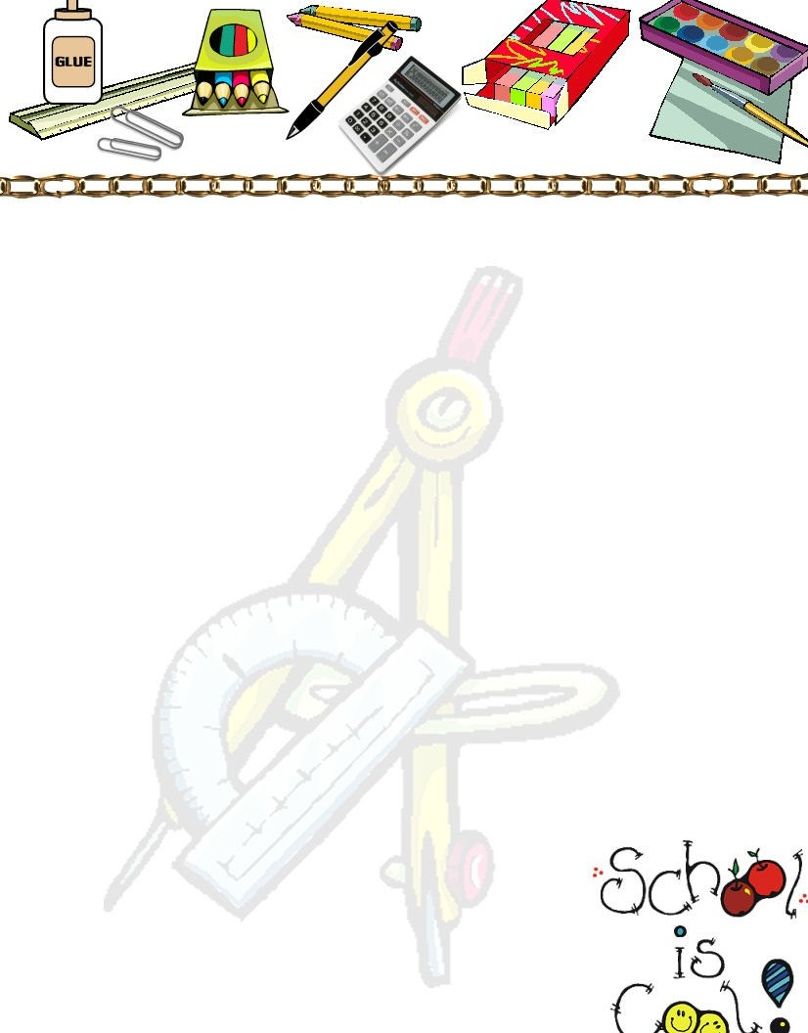

Autistic Support Supply List 2023-2024

Book Bag (no wheels please)
5 Rolls Paper Towels
4 Containers of disinfectant wipes
3 Composition Books
Change of clothing

** If your child is not potty trained, please supply pull-ups and/or diapers and wipes **

** Please put these items in a Pencil Bag labeled with your child’s name** 24 count box of crayons
- Large Glue Sticks

Please have these items at home:
Crayons Glue Scissors Pencils

Remember our school uniform is a blue top and khaki pants or shorts, gym days the students wear a gold top with blue shorts or sweat pants. Please adhere to the dress code.

All items are due the first week of school.

Thank you and I look forward to the new school year!! Mrs. Parker Room 108

